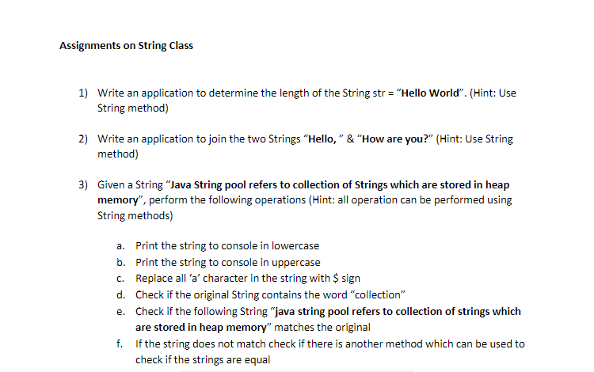

1.

**package** StringPractice;

**public** **class** LengtnOfString {

**public** **static** **void** main(String[] args)

{

String s = "Hello World";

System.***out***.println(s);

System.***out***.println(s.length());

}

}

2.

**package** StringPractice;

**public** **class** StringConcatination {

**public** **static** **void** main(String[] args)

{

String s1 ="Hello!";

String s2 =" How are you";

String s3 =s1.concat(s2);

System.***out***.println(s3);

}

}

3.

**package** StringPractice;

**public** **class** StringOperations {

**public** **static** **void** main(String[] args)

{

String s = "Java String pool refered collection of Strings Which are strored in Heap memory";

System.***out***.println("string in lower case:"+s.toLowerCase());

System.***out***.println("string in upper case:"+s.toUpperCase());

System.***out***.println("in string repalce a with $ case:"+s.replace('a','$'));

System.***out***.println("string contains case:"+s.contains("collections"));

String s1 = "Java String pool refered collection of Strings Which are strored in Heap memory";

System.***out***.println("String s is equal to s1 print:"+s.equals(s1));

String s2 = "java String pool refered collection of Strings Which are strored in Heap memory";

System.***out***.println("String s is equal to s1 print:"+s.equals(s2));

System.***out***.println("String s is equal to s2 print:"+s.equalsIgnoreCase(s2));

}

}

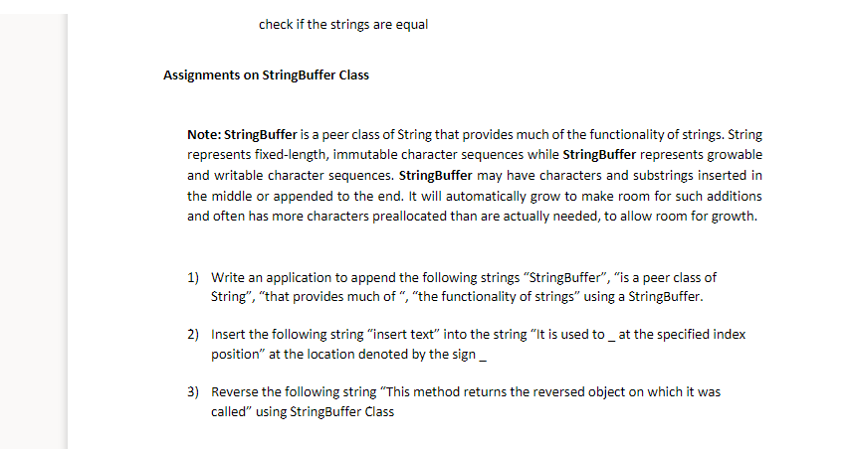

**1.**

**package** StringPractice;

**public** **class** StringBufferOperation {

**public** **static** **void** main(String[] args)

{

StringBuffer s = **new** StringBuffer("StringBuffer");

s.append("is a peer class of String");

s.append("that provides much of");

s.append("the functionality of strings");

System.***out***.println(s);

}

}

**package** StringPractice;

**public** **class** StringOperation1 {

**public** **static** **void** main(String[] args)

{

StringBuffer str = **new** StringBuffer("It is used to at the specified index position in the String");

str.insert(14, "insert the text ");

System.***out***.println(str);

}

}

3.

**package** StringPractice;

**public** **class** StringReverse {

**public** **static** **void** main(String[] args)

{

StringBuffer str = **new** StringBuffer("This method returns the reverse object on which it was called");

System.***out***.println("string before reversed:"+str);

**char** ch;

String rstr="";

**for** (**int** i=0;i<str.length();i++)

{

ch=str.charAt(i);

rstr=ch+rstr;

}

System.***out***.println("reverse String:"+rstr);

}

}

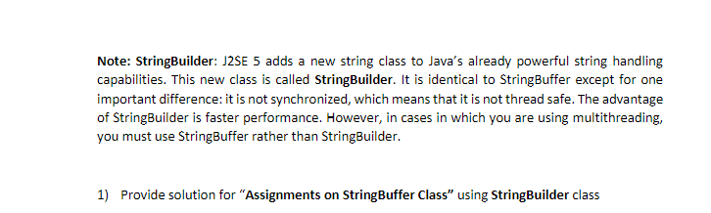

1.

**package** StringPractice;

**public** **class** StringBuilderOperations {

**public** **static** **void** main(String[] args)

{

StringBuilder s = **new** StringBuilder("StringBuffer");

s.append("is a peer class of String");

s.append("that provides much of");

s.append("the functionality of strings");

System.***out***.println(s);

}

}

2.

**package** StringPractice;

**public** **class** SringBuilderInsertion {

**public** **static** **void** main(String[] args)

{

StringBuilder str = **new** StringBuilder("It is used to at the specified index position in the String");

str.insert(14, "insert the text ");

System.***out***.println(str);

}

}

3.

**package** StringPractice;

**public** **class** StringBuilderOperation {

**public** **static** **void** main(String[] args)

{

StringBuilder str = **new** StringBuilder("This method returns the reverse object on which it was called");

System.***out***.println("string before reversed:"+str);

**char** ch;

String rstr="";

**for** (**int** i=0;i<str.length();i++)

{

ch=str.charAt(i);

rstr=ch+rstr;

}

System.***out***.println("reverse String:"+rstr);

}

}